Ahmad Miftahul Khoiri (17050623023)

**CRUD**

Insert One

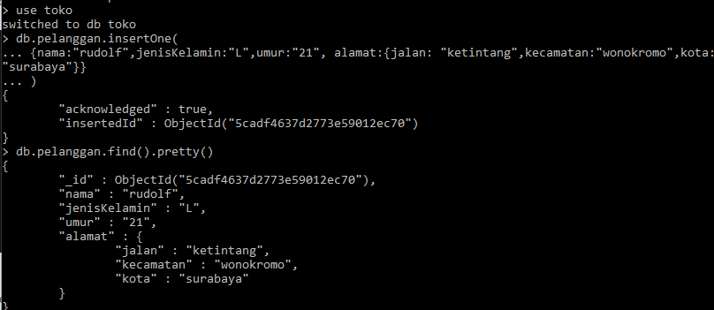

Insert Many

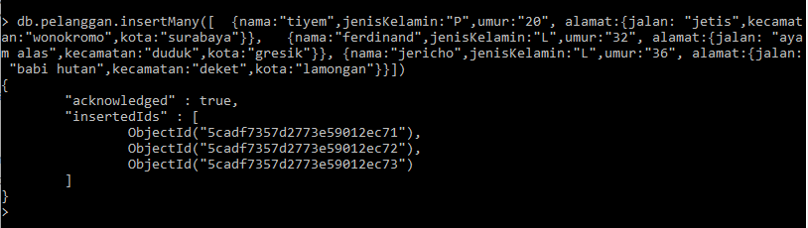

Delete

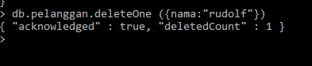

Update

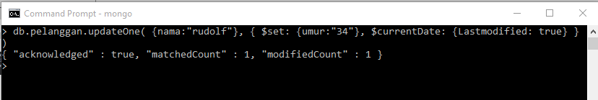

Specify Equality Match On a nested Field

